**International Institute of Professional Studies, DAVV Indore**



**Software design description on**

**An OpenSource software**

**“MELODY MUZIK”**

**https://www.melodymuzik.com/**

* **A music player**

**Version 1**

**By Avadhi Tomar**

**IT-2k19-06**

**Under the guidance of Dr Shaligram Prajapat sir**

**August 2021**

**IIPS DAVV Indore**

# INTRODUCTION

Android is an open source code mobile phone operating system that comes out

by Google. The music player in this project is application software based on

Google Android. Music is one of the best ways to relieve pressure in stressful

modern social life. The purpose of this project is to develop a player which

can play the mainstream file format. To browse and query the storage space

as well as operation of playing can be realised. Meanwhile, this software can

play, pause and select songs with the latest button and next button according to

sets requirements as well as set up songs.

## Melody Muzik UI (User Interface)

### Start Splash Screen

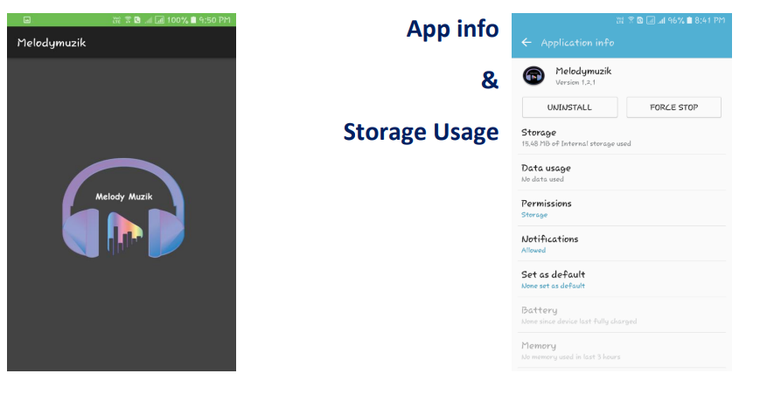

## Storage Permissions are Required to Read External SD card for Music files

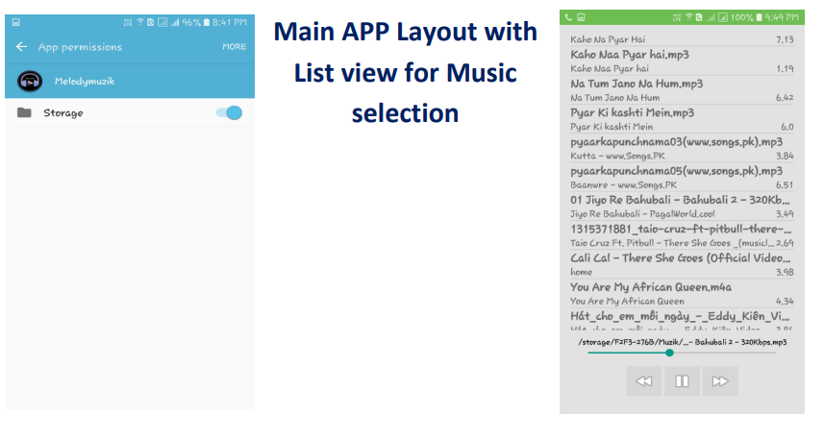

# CONCLUSION

Through the development of the music player on the Android platform, we get a clear understanding of The overall process of the system. The core part of the music player is mainly composed of the main interface, file browsing and song listing, Grasping the development of the music player has had the preliminary scale small features. Music player system realized the basic function of player: play, pause, rewind and fast forward,volume adjustment is performed through the Android System Itself, play mode, song search, seek bar.This development implicated the popular mobile terminal development technology. This is the combined management of Java language in the open-source mobile platform based on Linux system configuration file. The system realized the music player programming. This design of music player based on Android system requires elaborate design of the music player framework, by adopting ANDROID STUDIO 3.1.2 + Java language as technical support of this system, with the Android plug-in tools, and combination of Latest Android SDK version lead to the comprehensive and smoothly design and development of the mobile terminal.

### OTHER REQUIREMENTS

#### Maintain ability

The design will be updated based on any changes, which are done during

coding stage to maintain proper traceability.

#### Availability

Available for minimum API level 22 (Android Lollipop 5.1)

# REFERENCES

i. Various open source materials from Internet.

ii. Training notes.

iii. Discussion among the group and with guide.

iv. Some requirements are gathered through various books from library.